No.BB/e-Gov/NADRS/2010-11/ 42 dt at Chennai-8 the 08-06-2011

To
All SSA Heads,
BSNL,
T.N Circle.

Sub: NADRS issue on Windows 7 OS – reg.

Ref: AM(EB-NCR),ND e-mail dt.May 16th ,2011

Kind attention is invited to the above captioned subject. Complaint on non accessing of www.nic.in by NADRS subscribers due to window 7 OS have been received by this office. In this regard, the documents received from AM(EB-NCR),ND to resolve the above said issue are enclosed herewith. It may be utilized & NADRS - VPN access to www.nic.in site be verified.

/ sd /
Encl: As above Asst.General Manager (BBVAS),
O/o PGM-CFA,BSNL
TN Circle, Chennai – 8.

Windows 7 OS some of its Services given below are to be made it stop and make it manual.
For Mcafee Antivirus, only Realtime scanner services to be run remaining services may be disabled.
Steps are given below:
These steps are applicable for VPN over Broad Band with Windows 7 OS only : (FISHNET Project)
(Realcraft Project)
- Select the Control Panel → Administrative tools → Services → DNS client →
Stop the services → make it manual and apply it, as shown in the screen shot below:

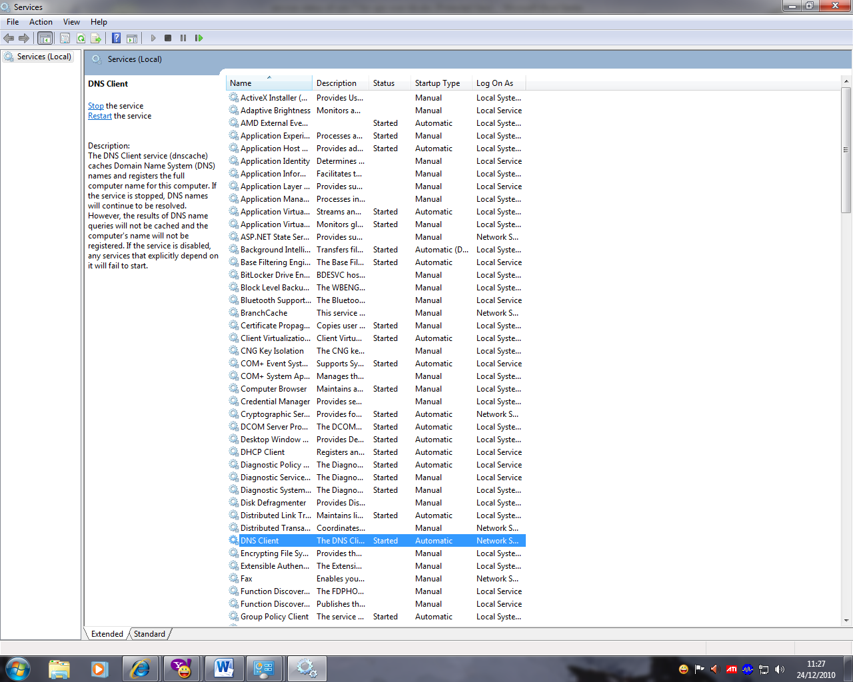

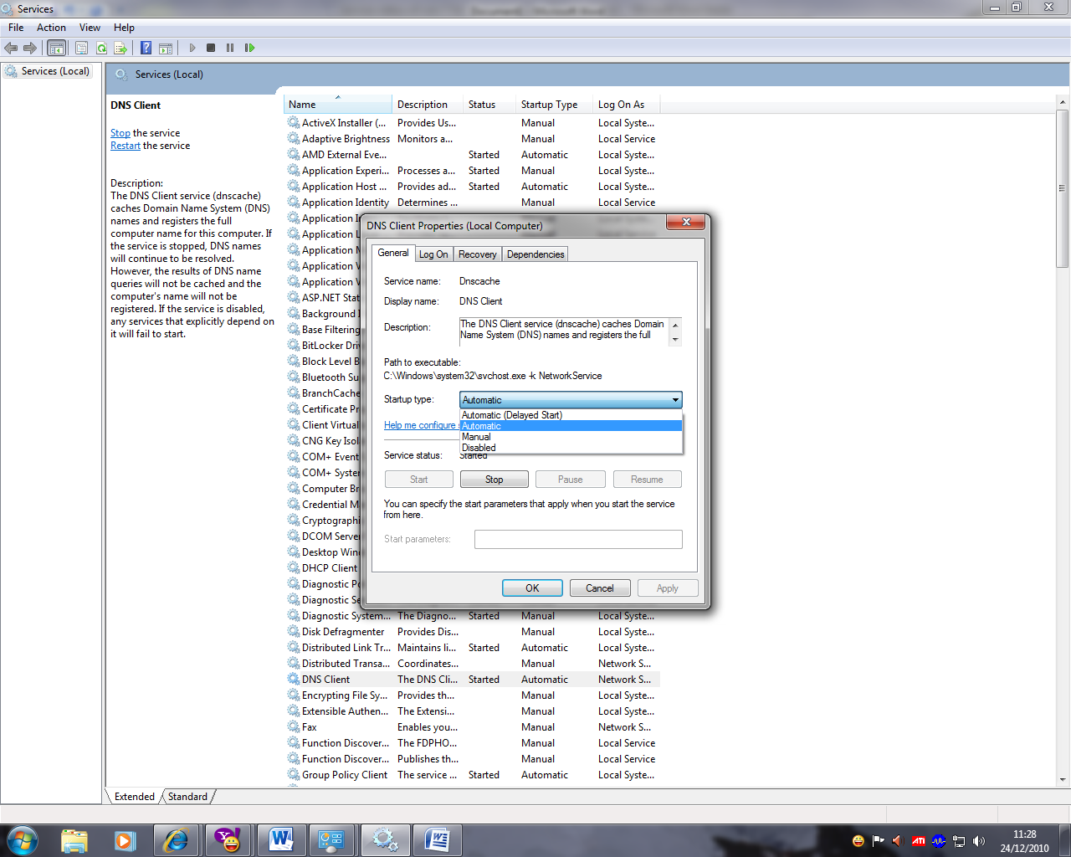
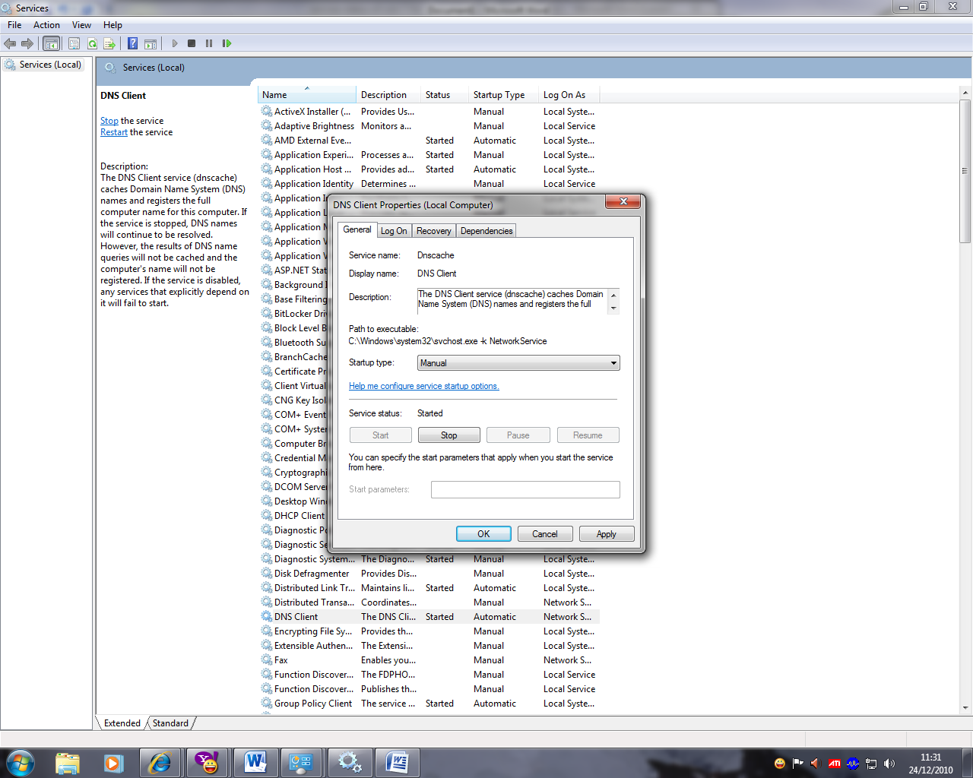
- Similarly stop the services of IPSecpolicyagent nd make it manual and apply it.
- Also disable the services of Mcafee services and except the Mcafee Realtime scanner.

Screen shot is given below :
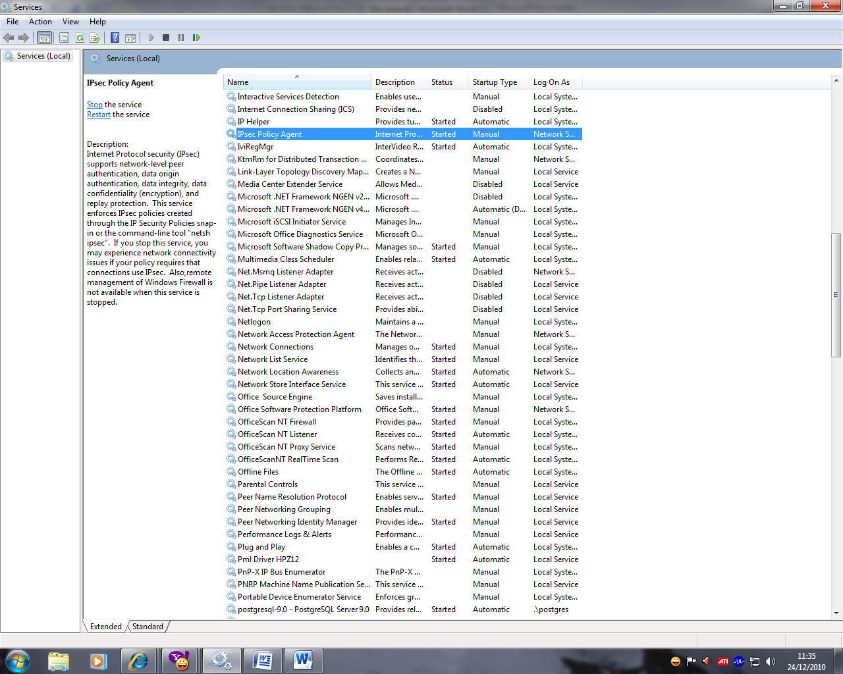

With regards,
T.S.Kumaresh & R.Rajasekaran
SSE, NIC, Pudcuherry

